Practical 2 omsai
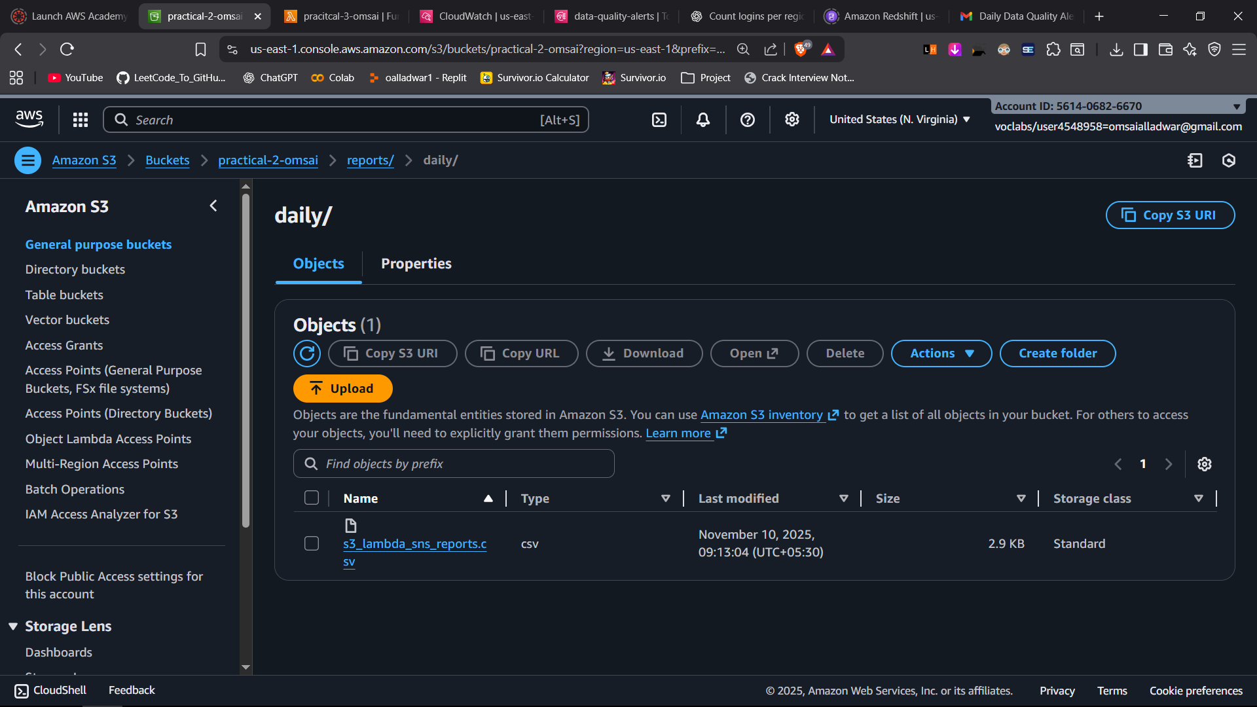
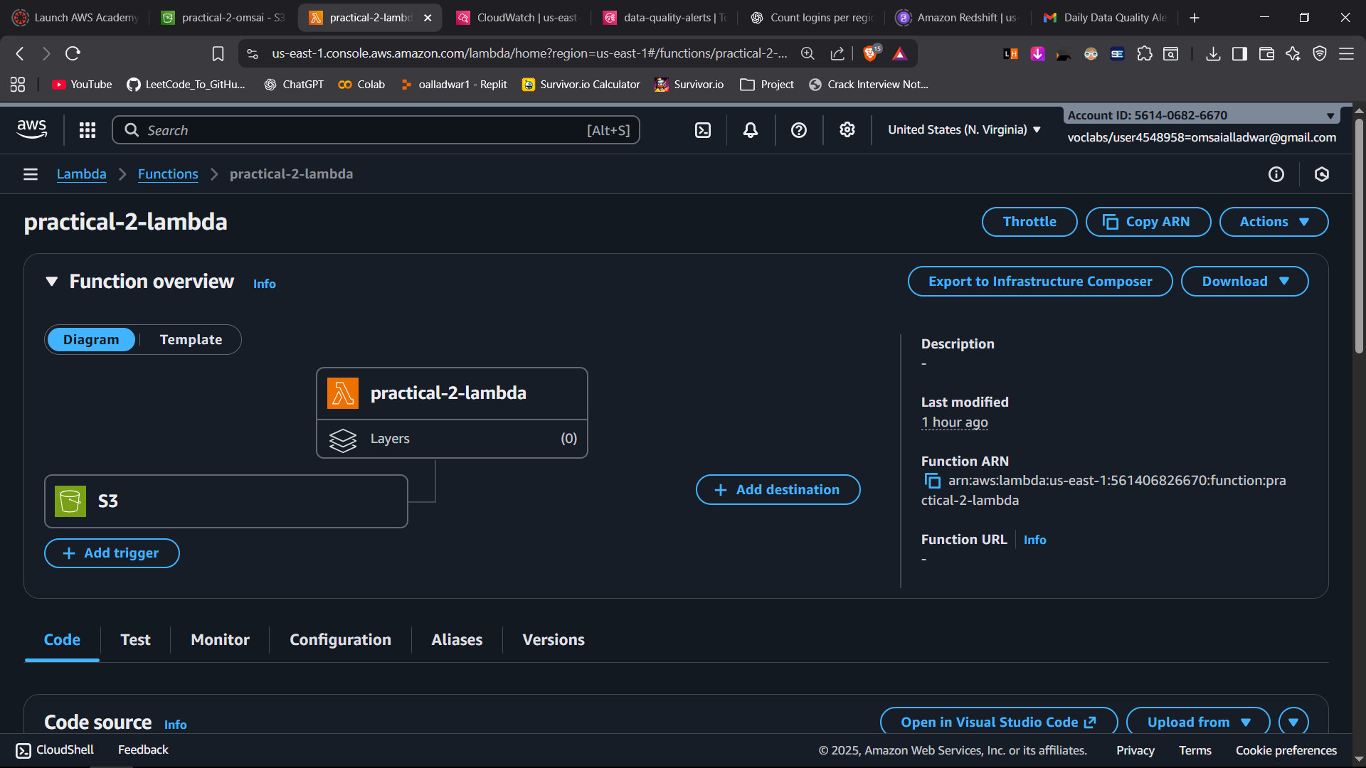
import boto3
import logging

logger = logging.getLogger()
logger.setLevel(logging.INFO)

sns = boto3.client('sns')
SNS_TOPIC_ARN = "arn:aws:sns:us-east-1:561406826670:daily-reports-alert"

def lambda_handler(event, context):
try:
record = event['Records'][0]

bucket = record['s3']['bucket']['name']
key = record['s3']['object']['key']
size = record['s3']['object'].get('size', 0)
upload_time = record['eventTime']

msg = (
"New file uploaded to S3\n"
f"Bucket: {bucket}\n"
f"File Name: {key}\n"
f"File Size: {size} bytes\n"
f"Upload Time: {upload_time}"
)

response = sns.publish(
TopicArn=SNS_TOPIC_ARN,
Message=msg,
Subject="S3 File Upload Notification"
)

logger.info("SNS message published id: %s", response["MessageId"])

except Exception as e:
logger.error("Error occurred: %s", str(e))
raise e

